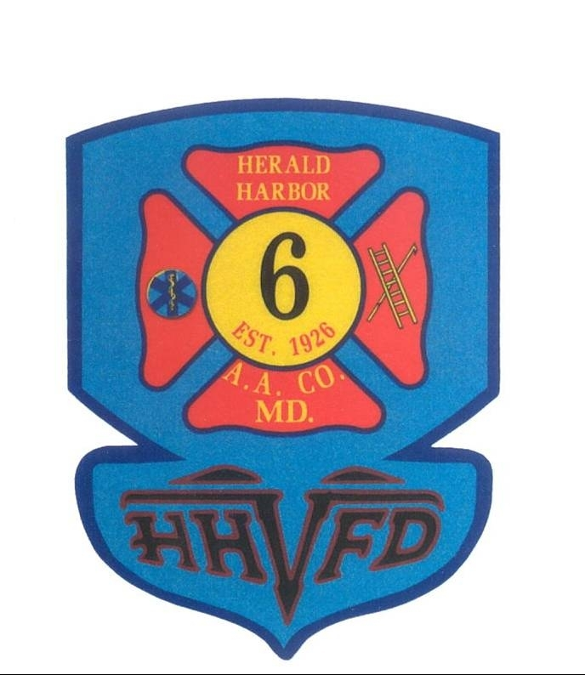

Herald Harbor Volunteer Fire Department

Commitment Agreement

To the Officers, Board of Directors and Members of the Herald Harbor Volunteer Fire Department. I present myself as a candidate for membership, and if accepted, I will cheerfully subscribe to the Constitution, By-Laws, Orders, and Procedures of the Herald Harbor Volunteer Fire Dept.

I understand that volunteering can be a rewarding experience but there are certain obligations I must meet in order to remain in good standing in the department. I agree to attend the monthly meeting and drills, to assist with the department’s public and community relation’s efforts; and to assist with maintenance and other tasks as assigned. I understand that it is expected that I will attend a combination of at least three events during my six months probationary period. The events can include drills, company meetings, fundraisers, station cleanups, tours of the firehouse, and community relations. I also understand that I am required to join a station committee and duty night. If I cannot meet an obligation, I will notify the appropriate officer immediately. I further agree to carry through with any responsibilities that I may take on as a member. I realize that my membership may be suspended and/or terminated by the Board of Directors.

I agree that while I am performing volunteer duties, I will act responsibly, ethically, and maturely. I understand that at certain times, information I obtain as a member must be kept confidential, and I promise not to breach confidentiality. I will also proudly wear my uniform in a clean and professional manner. I will do my best to protect and serve members of my community. I will support the department to the best of my ability. I will remember that safety is a priority while performing my duties in this department.

I agree to pay annual dues to the department when due. I also promise to return all items issued to me by the Herald Harbor Volunteer Department as listed on property receipts if my membership is to end. I understand that I am in a probationary, non-voting status during my first six months as a member in the department. I also understand that the probationary period ends only after an affirmative vote by the general membership of the Herald Harbor Volunteer Fire Department.

If I find it necessary to terminate my membership with the department, I agree to notify the President in writing.

Signature Print Name Date

________________________________________________________________________
Witness Signature Print Name Date

